University of Technology, Jamaica

Faculty of Engineering and Computing

School of Computing and Information Technology (SCIT)

Module Name: Introduction to Human Computer Interaction

Module Code: 3023

Tutor: Nadine Maitland

.

Authors:

Jade Robinson -1701077

Michael Jones -1604149

Andre Cameron -1701496

Due Date: March 23, 2021

**User Testing**

**Usability Specifications**: What measurable usability objective we are trying to achieve?

* We intend to design an online platform that is fast, intuitive and responsive for UTech students.
* We intend to offer an advanced search feature on the homepage of the website
* We also intend to offer a great user experience - one that Utech students will remember.

**Population:** How do you obtain representative users?

* We obtain representative users by creating a focus group with Utech students via whatsapp

**Roles:**

Andre: Time keeper, recorder of error and task times

Jade: Taking notes on critical events and watch the video camera

Michael: Directing the user

**Informed Consent:** Informed consent is important in data gathering to protect the respondents privacy. Informed Consent Form will be given to each user of the system.

**Data Gathering Forms:** These data gathering forms will be used to obtain feedback from the potential users. The forms will help to quickly and easily note task completion times, error, comment and critical events.

**Analysis of Results:**

**Quantitative**

**52% of respondents said that there recent experience was neutral**

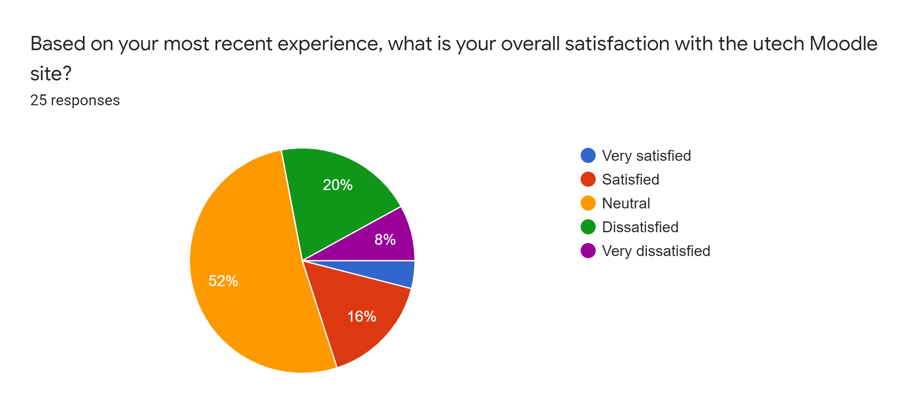

**Only 40% of respondents said that the interface was pleasant**

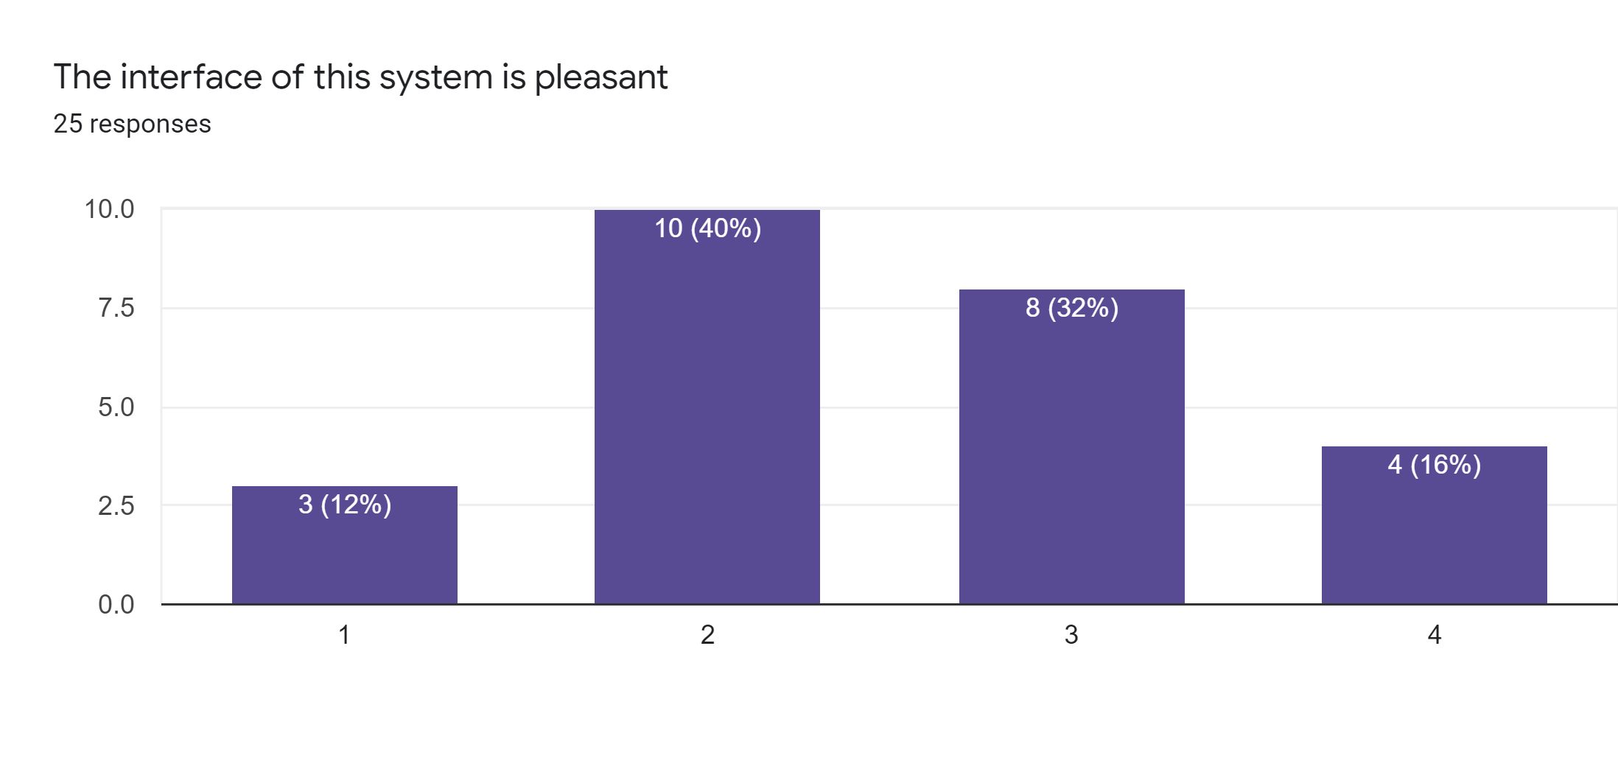

**68% of respondents said that they were able to complete their work efficiently**

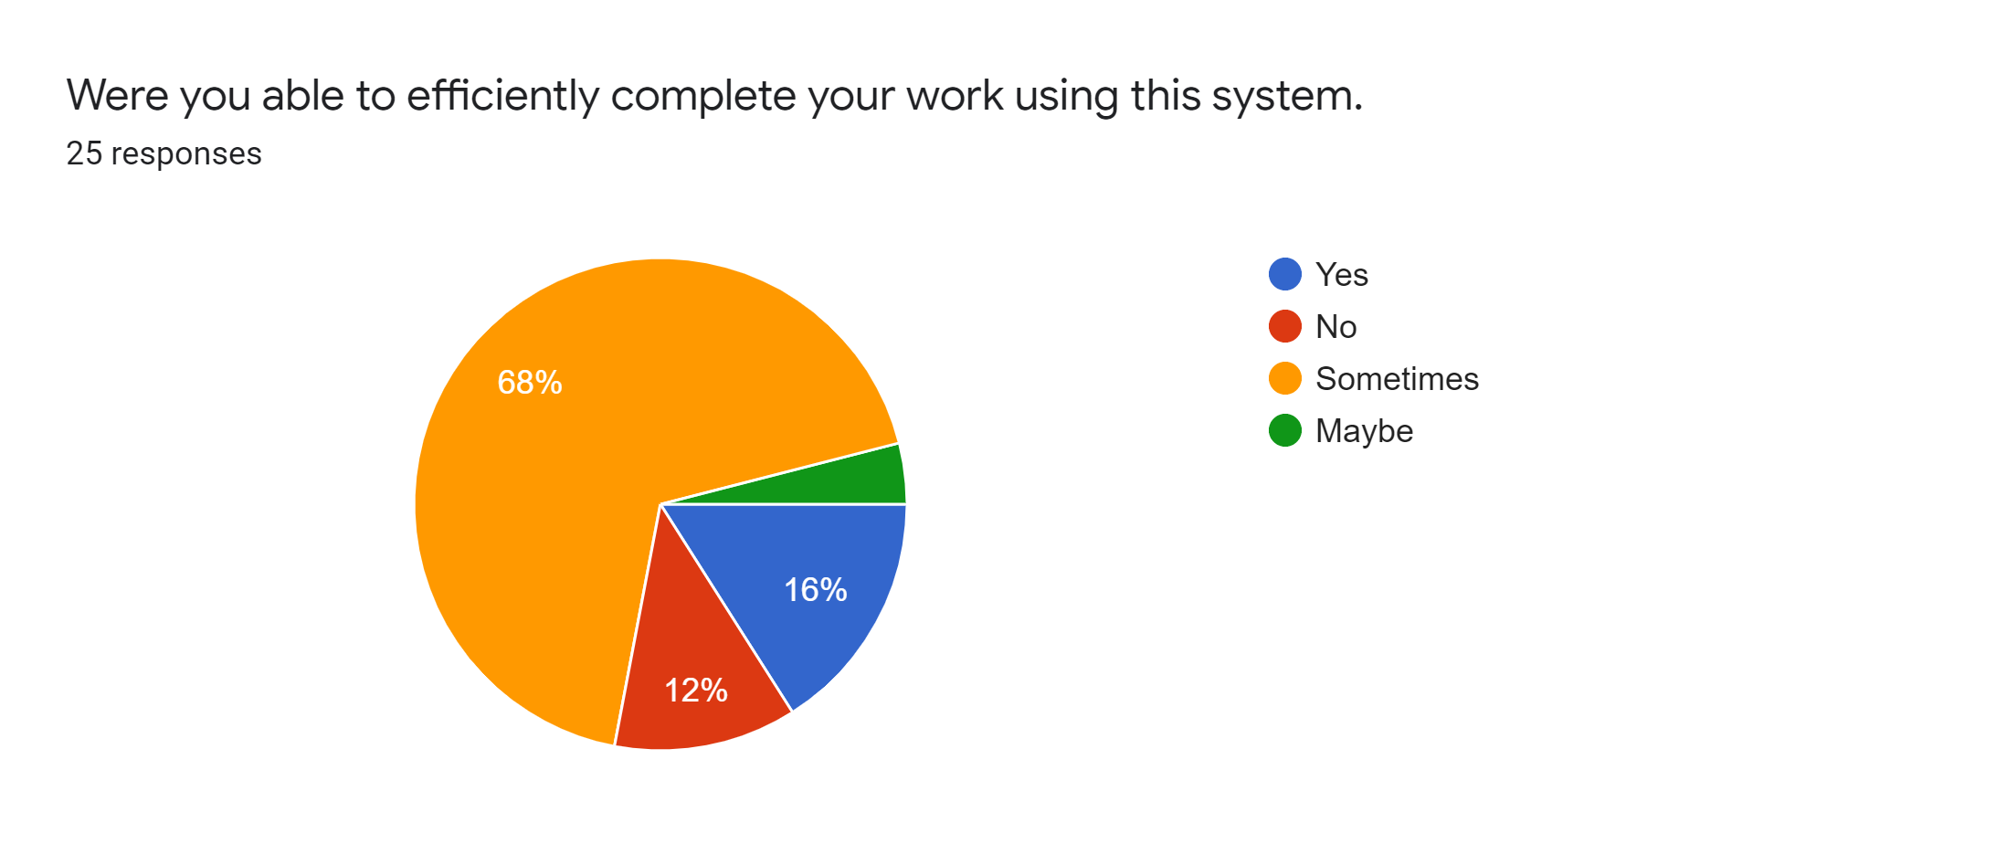

**Qualitative**

* The users pointed out that it would be much better if there was a search bar on the Home Screen so that the primary users can find their courses with less cognition.
* The feedback from users was how information is structured on the website is not very user-friendly.

**Heuristic (Expert) Review**

**UTech Online**:

* Fast, intuitive, not so easy to navigate and find courses.
* There are little or no colours and images present on the website.
* Absence of search feature on the homepage of the website.

**UTech Online 4.0**:

* Much more faster, intuitive and responsive
* More vibrant colours and images are used.
* Search feature on the Home Screen.
* Easier to navigate.
* Good user experience (UX)